MATHEMATICS SPECIALIST

MAWA Year 12 Examination 2018

Calculator-assumed

Marking Key

© MAWA, 2018
Licence Agreement
This examination is Copyright but may be freely used within the school that purchases this licence.
- The items that are contained in this examination are to be used solely in the school for which they are purchased.
- They are not to be shared in any manner with a school which has not purchased their own licence.
- The items and the solutions/marking keys are to be kept confidentially and not copied or made available to anyone who is not a teacher at the school. Teachers may give feedback to students in the form of showing them how the work is marked but students are not to retain a copy of the paper or marking guide until the agreed release date stipulated in the purchasing agreement/licence.

The release date for this exam and marking scheme is
- the end of week 8 of term 2, 2018

Question 8 (5 marks)

Solution
If then if we have
.

Since we have assumed that we reject the negative square root.

If then

Since we have assumed that we reject the positive root.

Hence the solution is or .

Mathematical behaviours | Marks
- calculates the correct root assuming that (2 marks)  - calculates the correct root assuming that (2 marks)  - states the overall solution correctly | 1  1  1

Question 9 (a) (3 marks)
Solution
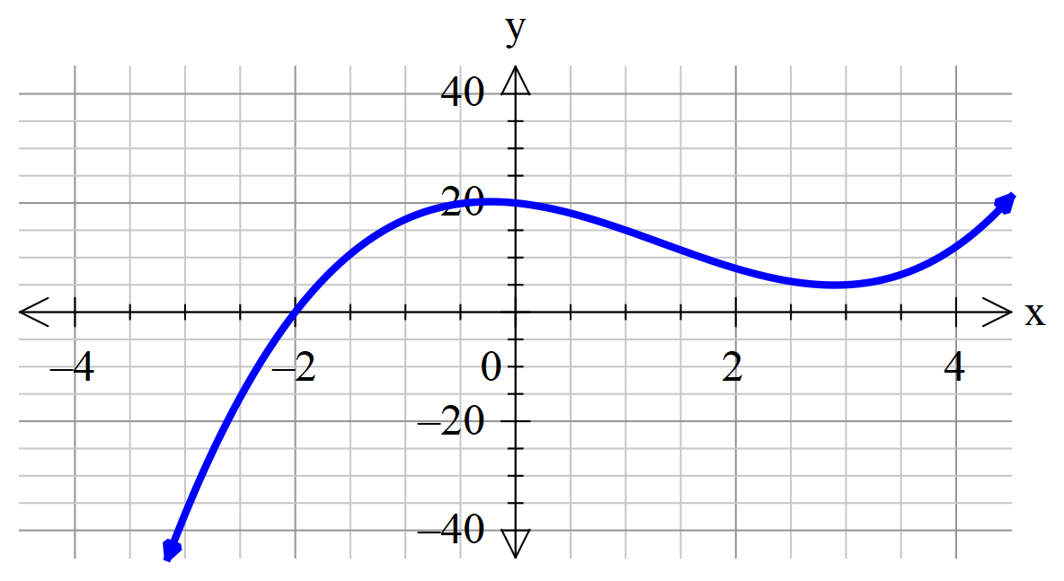

From the graph it appears that has a zero at
We evaluate
So by the factor theorem is a factor of

Mathematical behaviours | Marks
- obtains as a possible zero of p  - demonstrates that  - deduces that is a factor of | 1  1  1

Question 9(b) (3 marks)
Solution
Long division gives that

If by either using the quadratic formula or completing the square

Hence and are the conjugate linear factors of

Mathematical behaviours | Marks
- identifies the correct quadratic factor  - determines correctly the zeros of the quadratic factor  - states correctly the corresponding conjugate linear factors | 1  1  1

Question 10(a) (2 marks)
Solution
Mathematical behaviours | Marks
- correctly states the horizontal and vertical components of  - simplifies correctly | 1  1

Question 10(b) (2 marks)
Solution
The acceleration is

Mathematical behaviours | Marks
- integrates to determine  - determines the constant and states the correct | 1  1

Question 10(c) (6 marks)
Solution
Mathematical behaviours | Marks
- integrates to determine (accept assumption of constants of integration as 0 from initial conditions, without statement)  - uses vertical component of determine the time when max height is reached  - determines the max height  - recognises that the max horizontal distance when vertical component =0  - determines the time when max distance is reached  - determines max distance | 1  1  1  1  1  1
Question 11 (a) (2 marks)
Solution
Now
and
Since a pair of adjacent sides in the parallelogram P have the same length, all sides have the same length.

Hence P is a rhombus.
Mathematical behaviours | Marks
- calculates the correct values of and  - makes a valid deduction about the lengths of all sides of P | 1  1

Question 11 (b) (3 marks)
Solution
Denote . Then
Denote . Then
Hence
So the required angle is 2.21 radians (correct to 2 decimal places)
Mathematical behaviours | Marks
- determines correctly the value of  - determines correctly the value  - gives the required answer to the prescribed accuracy | 1  1  1

Question 11 (c) (2 marks)
Solution
We see that
and that

Hence it follows that
Mathematical behaviours | Marks
- evaluates correctly the value of 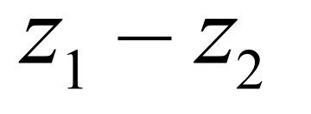  - evaluates correctly the value of . | 1  1

Question 11 (d) (4 marks)
Solution
The diagonals of P are and .
From part (c) we deduce that …….(i)

Hence one diagonal is twice as long as the other.

Also we have that
………(ii)
Hence the angle between the diagonals is .

Mathematical behaviours | Marks
- derives the result (i)  - deduces the correct ratio of the lengths of the diagonals  - derives the result (ii)  - deduces the correct angle between the diagonals | 1  1  1  1

Question 12(a) (3 marks)

Solution
Since the function involves a square root we need to check that the quadratic is positive for all real values of.
As
the function is defined for all real values

Mathematical behaviours | Marks
- notes that we need to show that the contents of the square root is positive  - either completes the square or shows the quadratic never equals zero  - deduces the required result | 1  1  1

Question 12(b) (3 marks)

Solution
If then
This then implies that or

Mathematical behaviours | Marks
- forms an equation without the square root expressing the fact that  - solves the equation  - states the two possible solutions | 1  1  1

Question 12(c) (3 marks)

Solution
The function is not one-to-one.
If the function were 1-1 then would force .
Since here we have the possibility that we do not have a 1-1 function
Mathematical behaviours | Marks
- states the correct conclusion  - indicates the property that must be satisfied by a 1-1 function  - justifies why this function does not possess this property | 1  1  1

Question 13 (6 marks)

Solution
If then .
Also
so that for .
Hence or .
Written in polar form, cis with or .
Moreover, cis cis cis cis
and so the solutions are
. , and .

Mathematical behaviours | Marks
- derives the result that  - deduces the correct value of  - obtains one value of  - determines all four possible values of  - writes down the the real and imaginary parts of the four ‘‘cis’ values  - solves correctly for the real and imaginary parts of all four solutions | 1  1  1  1  1  1

Question 14(a) (3 marks)

Solution
If
Therefore the inverse function is

(Alternatively students may define the other branch with so .)

Mathematical behaviours | Marks
- writes the equation  - solves for  - states correct inverse function | 1  1  1

Question 14(b) (2 marks)

Solution
Domain is
Range is
(If student took the alternative definition the range becomes .)

Mathematical behaviours | Marks
- states correct domain  - states correct range | 1  1

Question 14(c) (2 marks)

Solution
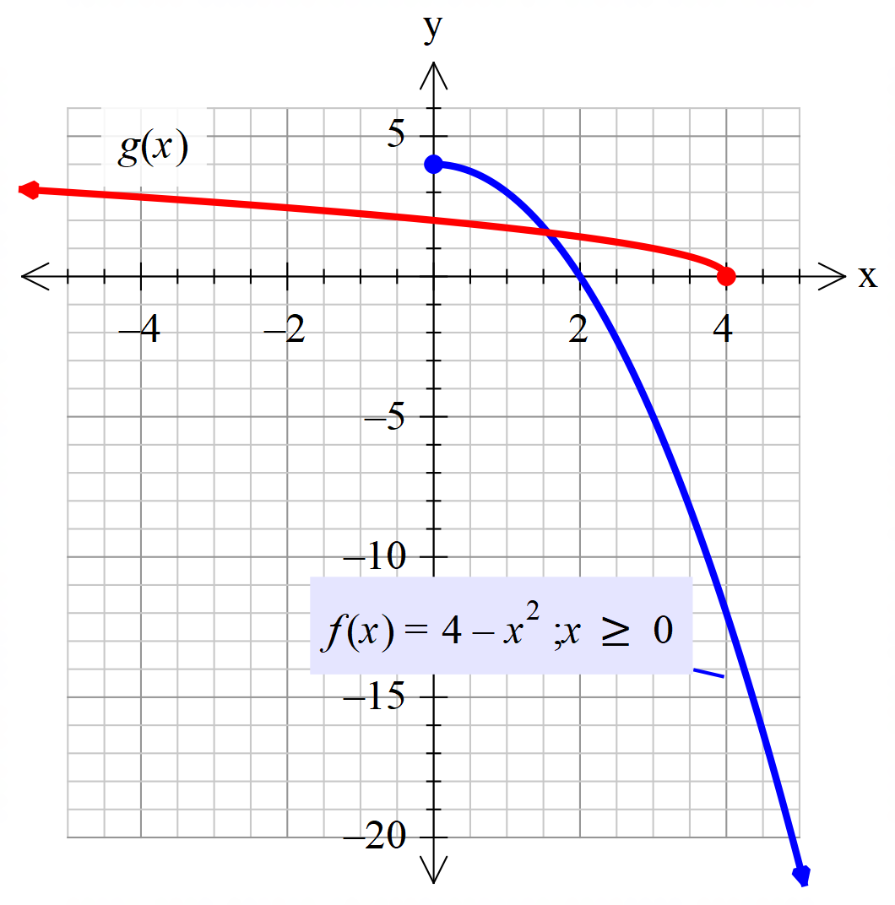

Mathematical behaviours | Marks
- gives neat sketch of  - gives neat sketch of | 1  1

Question 14(d) (2 marks)

Solution
The two graphs are reflections of each other in the line
Mathematical behaviours | Marks
States the correct geometrical relationship with marks  - for mentioning reflection  - for giving the equation of the line of reflection | 1  1

Question 15(a)(b) (3+2 marks)

Solution
since
Point moves in a horizontal circle, +2 units above the as indicated by the 2.
The centre of the circle is (0,0,2) and the radius is 1 unit.
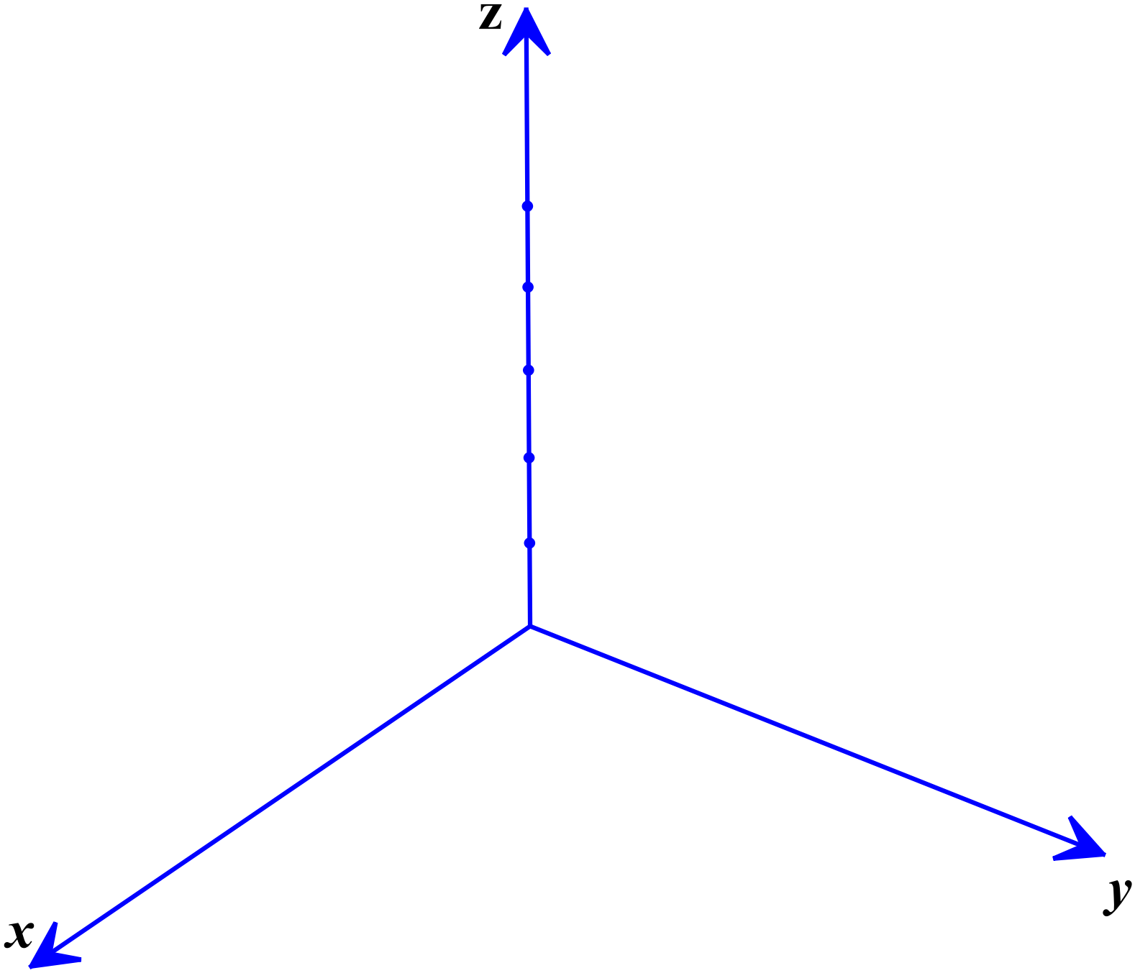At so the particle starts at (1,0,2) and at so the particle moves in an anticlockwise direction.

Mathematical behaviours | Marks
- indicates that the particle moves in plane parallel to the and 2 units above it  - indicates that it is a circle  - states the centre and radius of the circle  - indicates that the particle moves in an anticlockwise direction  - provides an appropriately labelled diagram of the circle in roughly the right position | 1  1  1  1  1

Question 15(c) (2 marks)
Solution
The particle remains at a constant distance from the origin.
Mathematical behaviours | Marks
- determines the correct distance  - states that the distance from the origin is constant over time | 1  1

Question 15(d) (2 marks)
Solution
The position vector is given by $p\left(t\right)=\cos\left(2t\right)i+sin\left(2t\right)j+2k$
Differentiating
Mathematical behaviours | Marks
- determines the correct velocity  - (allow one mark if attempts to differentiate but makes an error) | 2

Question 15(e) (2 marks)
Solution
Given moves in a circle in the , with centre (0,2) and radius 2, the vector equation is with
Mathematical behaviours | Marks
- states the correct cartesian equation  - remembers to state that | 1  1

Question 15(f) (3 marks)
Solution
Mathematical behaviours | Marks
- indicates the need to determine  - determines  - calculates the correct distance | 1  1  1

Question 16(a) (4 marks)

Solution
By De Moivre’s theorem we have
.
Expanding and taking real parts gives

Mathematical behaviours | Marks
- uses De Moivre’s theorem appropriately  - expands the fourth power of the expression correctly  - takes the real parts of each side  - replaces and simplifies to obtain the result | 1  1  1  1

Question 16 (b) (5 marks)

Solution
Let where . Then by part (a) we have
Hence the maximum and minimum values of are .

At maximum values so that or within the range.
Since we have .

At minimum values so that or within range whence .
In summary, the maximum value of $p(x)$ is 1, and occurs at $x=1,0 \text{or}-1$
and the minimum value of $p(x)$ is -1, and occurs at $x=±1/\sqrt{2}$
Mathematical behaviours | Marks
- derives 1 and -1 as the extreme values of  - determines the correct values of θ at the maximum  - infers the corresponding correct values of  - determines the correct values of θ at the minimum  - infers the corresponding correct values of | 1  1  1  1  1

Question 17(a) (4 marks)

Solution
We have . Domain is and range is (all real numbers)
Similarly . Domain is and range is (all real numbers)

Mathematical behaviours | Marks
- determines the two composite functions correctly (one mark for each)  - states domain and range of  - states domain and range of | 1  1  1

Question 17(b) (2 marks)

Solution
If then

Mathematical behaviours | Marks
- forms an appropriate equation for  - solves correctly | 1  1

Question 18(a) (1 mark)

Solution
Since plane is parallel to the , and everywhere on the plane the equation is (in vector form the equation is r.i)
Mathematical behaviours | Marks
- states the correct equation of the plane | 1

Question 18(b) (3 marks)

Solution
Largest sphere will have a diameter = 3 units, so the radius = 1.5 units and centre =
Vector form:
Cartesian form:
Mathematical behaviours | Marks
- states the centre and radius of the sphere  - states the vector equation  - states the Cartesian equation | 1  1  1

Question 18(c) (3 marks)

Solution
Mathematical behaviours | Marks
- determines the cross product of two appropriate vectors  - uses the cross product to determine the equation of the plane  - states the correct plane equation | 1  1  1

Question 18(d) (5 marks)

Solution
- Substituting into
so its position vector is i+j + k
Mathematical behaviours | Marks
- determines the position vector for  - uses the position vectors of and to determine the vector equation of the line  - states the equation of the line in equivalent parametric form.  - substitutes into the equation of the plane  (or whatever found in part (c))  - states the position vector of the point of intersection | 1  1  1  1  1

Question 18(e) (3 marks)

Solution
Using the dot product of and or the angle between vectors on a CAS calculator the angle between the line and the plane is 91.6°.
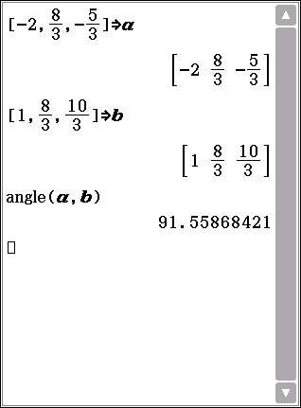

Mathematical behaviours | Marks
- determines an appropriate vector in the line (e.g )  - determines an appropriate vector in the plane (e.g)  - states the angle between the plane and the line (accept any suitable rounding) | 1  1  1

